Software Requirements Specification Template

Car Pooling Application

Software Requirements Specification

Version 1.4

05-26-2022

Team Members
Nagamani Yalla
Sai Lavanya Peddinti
Sri Harsha Kikkuri
Dinesh Yerramothu
Shashidhar Reddy Peddireddy

Submitted in partial fulfilment
Of the requirements of
CSIS 44-691 Graduate Directed Project 1

Revision History

Date | Description | Author | Comments
5/16/2022 | Version 1.1 | Team | First Revision with updated functional requirements as per client requirements
5/17/2022 | Version 1.2 | Team | ER diagram added to the design section
5/18/2022 | Version 1.3 | Team | Revision of the ER diagram
5/26/2022 | Version 1.4 | Team | Prototype and Data Flow Diagram added

Document Approval

The following Software Requirements Specification has been accepted and approved by the following:
Signature | Printed Name | Title | Date

Table of Contents

Table of Contents Page Number

- Introduction
  - Purpose
  - Scope
  - Definitions, Acronyms, and Abbreviations
  - References
  - Overview
- General Description
  - Product Perspective
  - Product Functions
  - User Characteristics
  - General Constraints
  - Assumptions and Dependencies

- Specific Requirements
  - External Interface Requirements
    - User Interfaces
This app is designed for people wanting to travel through carpooling and drivers. The product will be distributed to a web site, and all system users will access the system through a web interface that contains multiple pages based on system functionality, such as a first page for registration and login functionality. Every user has their own username and password to have access to the system. There will also be a database that saves and manipulates all the users' data. The website will merely serve as an interface for all user data stored in the database and the execution of the functionalities offered.
User data will be transferred to the database after registration. E-mail verification will be used during the sign-up process to verify user details. Following that, users can register using the web interface. The user will be able to log out at any time after logging in.

    - Hardware Interfaces:
Our application does not have a specific hardware interface. The web application is hosted on a PHP application server. It is web based and is compatible with all the browsers and can be run on any operating system and processor. Below are the few basic hardware requirements:
- System: Microsoft Windows
- Processor: Standard processor with a speed of 1.8 GHz
- RAM: 512 MB RAM
- Hard Disk: 80 GB

    - Software Interfaces:
Because all system data, including as user and route information, must be saved in a database for subsequent use and system functionality, a database management system is a mandatory software product for Carpool systems.
For that reason, the MySQL database management system is utilized, and it provides a beautiful open-source user interface that shows table and row data in a well-formatted style for developers to design and administer the database.
HTML and the Bootstrap library will be utilized to create a visually appealing user interface for the system.
Http Requests in JavaScript and PHP languages will be used to handle these clients and server-side attractions.
Below are the software tools we are using in the project:
- Database: MySQL
- Server: PHP
- Front end: HTML, CSS AND JAVASCRIPT
    - Communications Interface:
The person giving ride and the one taking it can look up the phone numbers of each other on the website and communicate. They should however have access to internet to get the details of the rider and the person opting for ride.
  - Functional Requirements:
    - General application requirements
a. Registration (Sign up/Sign-in): Users can register for the first time in the application, and their information will be recorded in the database.
b. Login: Both the driver and the passenger must be logged in to use this application. The user is then prompted to connect using this application after proceeding to sign in/up.
c. Forgot Password: When user forgets their password, they can retrieve password by clicking on Forgot password.
d. Retrieve password: Users can retrieve password by sending a verification link to registered email address or by sending an OTP to their phone number.
e. Profile Information: Users have Name, Date of Birth, phone number, and email address are available here.
f. Update profile information: All users have an option to change their profile information but they can only update Phone number periodically for every 30 days.
g. Social media sharing: Users should be able to publish their activities on the app on social media to attract additional users and assist them in finding passengers. A suggestion for sharing trips creation, trips registration or check in should pop-up whenever those previous actions are performed. The sharing should be authorized by the users and not done automatically by the application in order not to spam the users account and gain the users confidence.
e. Rate driver/passenger: Both the driver and passenger can rate each other in other to gain reputation. The importance of the rating is to encourage users to be helpful and nice during the trip so that they gain popularity in the application. It is also a way to ensure users of who can be trusted or not. The ratings represent a relative guarantee for the users to trust each other.

    - Regular trips
a. Create new regular trip
The driver can create new trips and provides following information about the trip:
- Origin: A point where driver meets the passenger’s location.
- Destination: End point/drop off location of the passenger.
- Departure time/date: The time/date when the ride begins.
- Arrival time/date: The time/date when the ride ends.
- No. of Passengers: The number of seats available in ride.
- Car Information: It has car number, color, image of the driver’s car.
- Travel Preferences: Includes count of bags, Face mask.
b. Search for regular trips and book the rides
A passenger can search/book a ride from available rides which are created by drivers. Following are search/booking criteria for users.
Search Criteria:
- From: Prearranged place where driver has to pick up the passenger.
- To: A desired place where passenger wants to be left.
- Date & Time: Services required for the passenger under the booking.

Book Criteria: User can choose a ride from available rides and book a ride accordingly. Booking confirmation will be sent to email and also updated in booking history.
c. Communication: If users have any issue related to trip, users can communicate through chat or call facilities.
d. Check-in trip
When the driver or passenger arrives at the accepted meeting spot at the time specified, he can check-in to alert the other user. When someone checks in, a message is sent to all carpoolers informing them that someone has arrived at the meeting point.
e. Admin Privileges:
According on his availability, Admin can accept or decline the ride. The ride would be marked as cancelled/ride unavailable for the individual who was waiting for it.
f. Payment:
The person taking the transport has the option of paying with cash or with any other payment app. Essentially, after the cost is revealed, the complete price for the person must be paid to the rider, who can then decide and pay in the mode of his choice.
g. Vehicle details/License check:
The person providing the ride must offer information about his car, including its capacity and how many people he is ready to transport. To register with the app and provide rides, the Rider will need to have a valid driver's license.
g. Booking History:
Previous trips must be included in the history, as well as payment history, Rider information, the date and time of the ride, and the destination and pickup location information.
    - Logout:
After the ride has been completed and payment has been made, the user should logout and a successful screen should show indicating that the logout has been accomplished successfully.

  - Use Cases
  - Class/Objects
  - Non-Functional Requirements
    - Performance
Since the meeting between the driver and passengers is done through alerts, the application must respond quickly. In other words, the server should be able to handle and transmit notifications in real time. The application should handle multiple users sending queries at the same time.
    - Reliability
The carpooling system should be accessible when needed
- When a rider wants to offer a ride, the application's availability should be determined based on the car's capacity, the number of passengers, and the fee.
- When a person wants to use the carpooling system, they must be able to book a trip and arrive at their desired location.
Since a lot of information about the trips and check in are available in the application, it must be highly available and guarantees a good server up-time. The server should allow only 1 hour down time per year which is 99.99% up-time.
    - Security
The application should ensure the privacy of the users including the trips they take part in, their social media accounts and their accounts. The login system should authorize users can post and edit their own information.
    - Portability
Our carpool system would be hosted on web and hence can be deployed, accessed, and managed – regardless of delivery model.

  - Inverse Requirements:
- The Rider/person taking the ride cannot utilize this web application if the user is not having phone number.
- Everyone has to login to the app and have a mandatory username to book a ride.
- The Rider should have a valid license.
  - Design Constraints
  - Logical Database Requirements
Data Access: In this project, MySQL Database will be utilized to save the user and driver details. The database would include the driver details table, User details table and the generic table which would hold the payment details, time and date of booking and ride history.
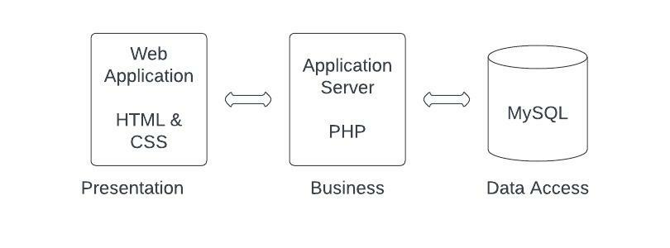
  - Other Requirements
  - Prototypes (for complete project)
  - Use Case Diagrams
- Design
4.1. ER diagram
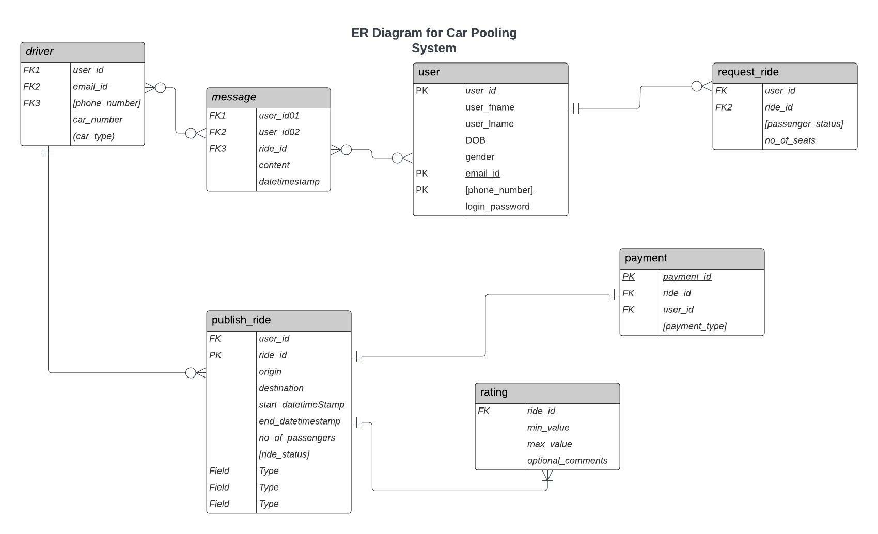

4.2. GUI
Homepage
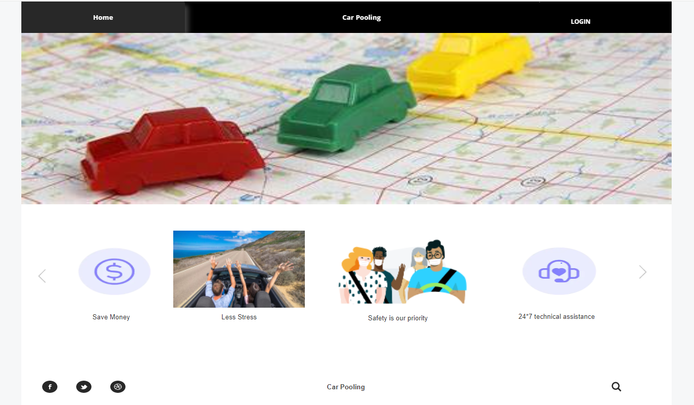

Login Page
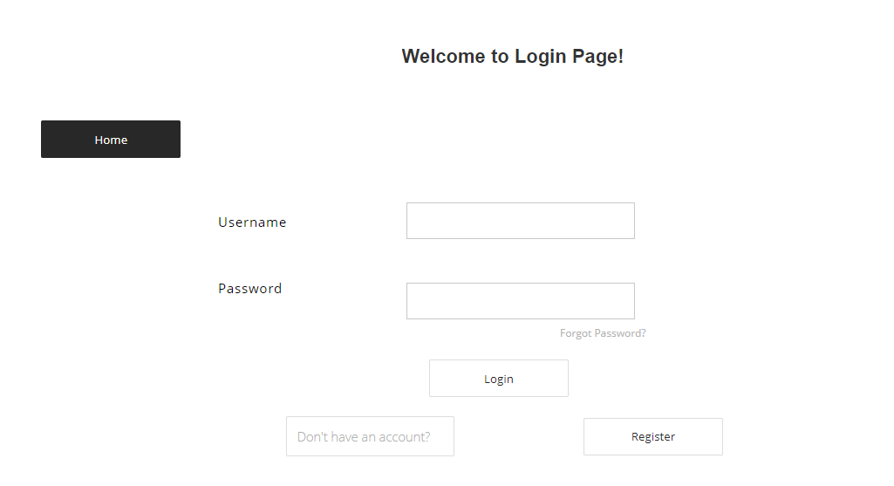

Forgot Password (OTP)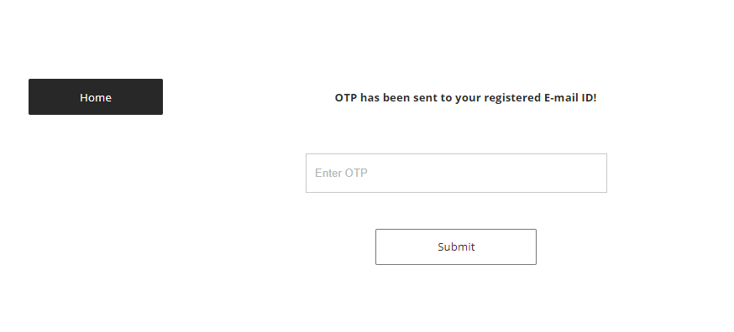
Sign up
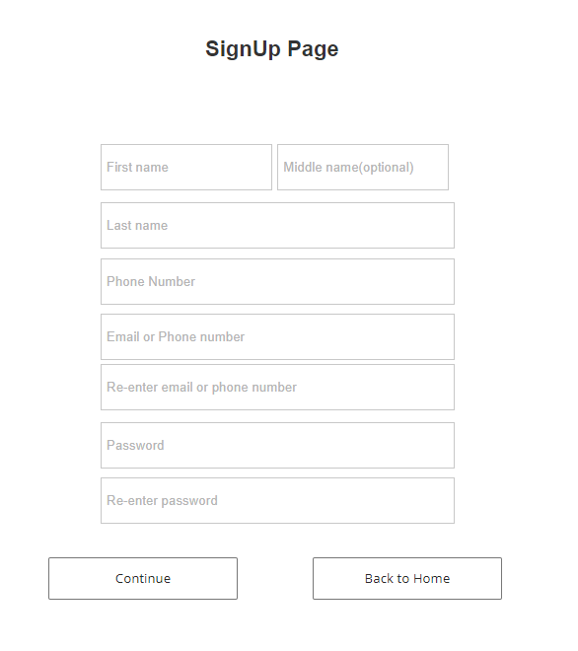

Sign up Verification
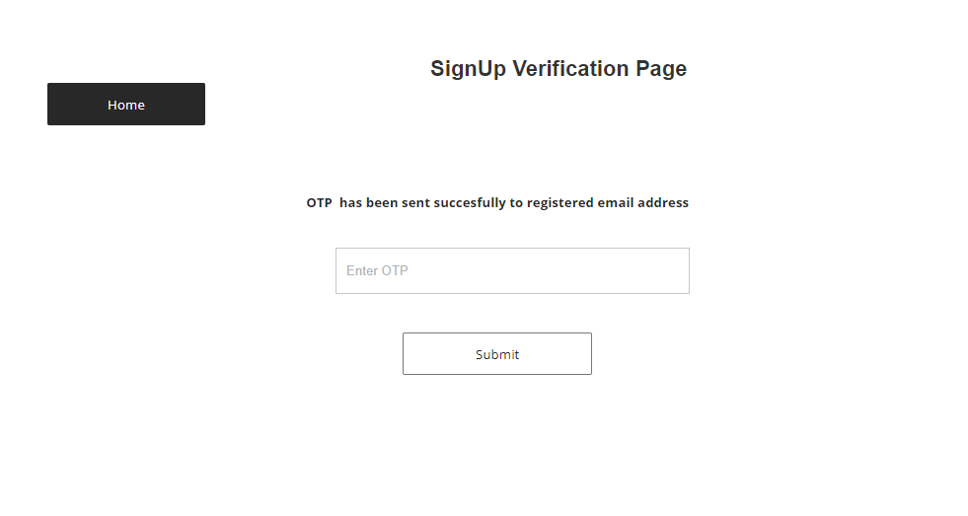

Verification Successful

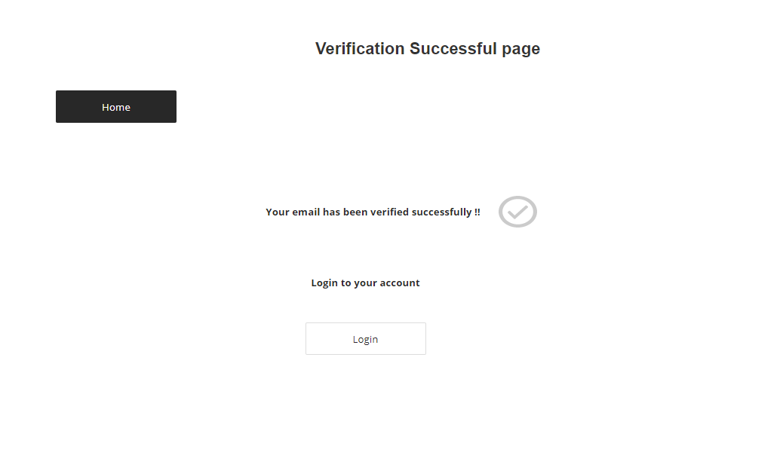

Welcome
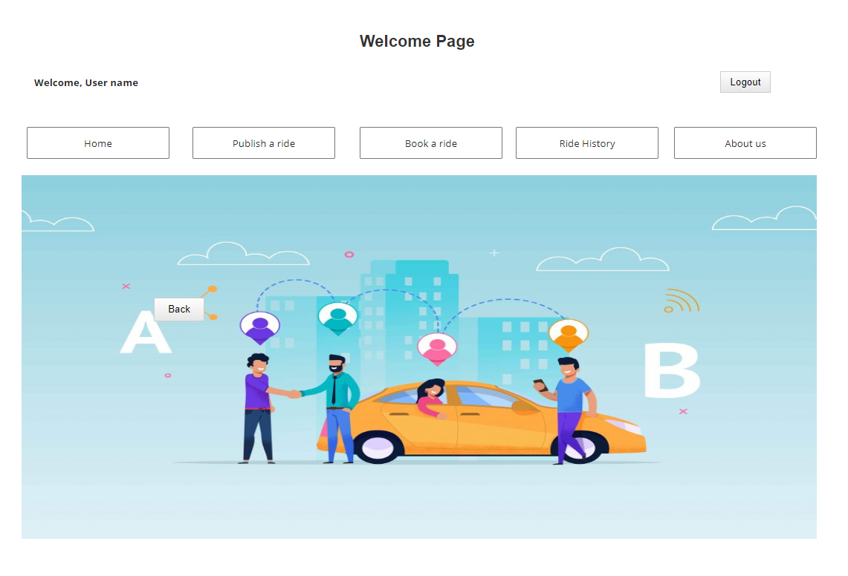
Publish Ride
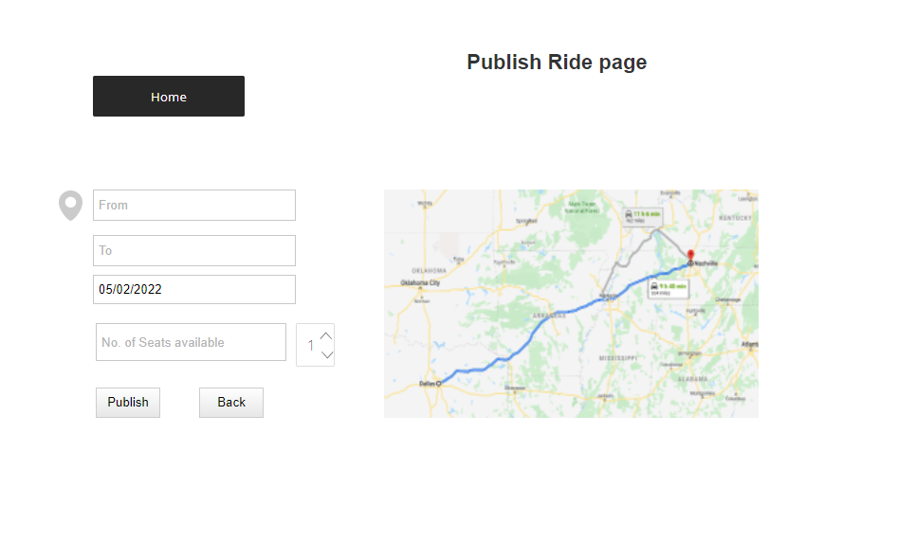
Book a Ride
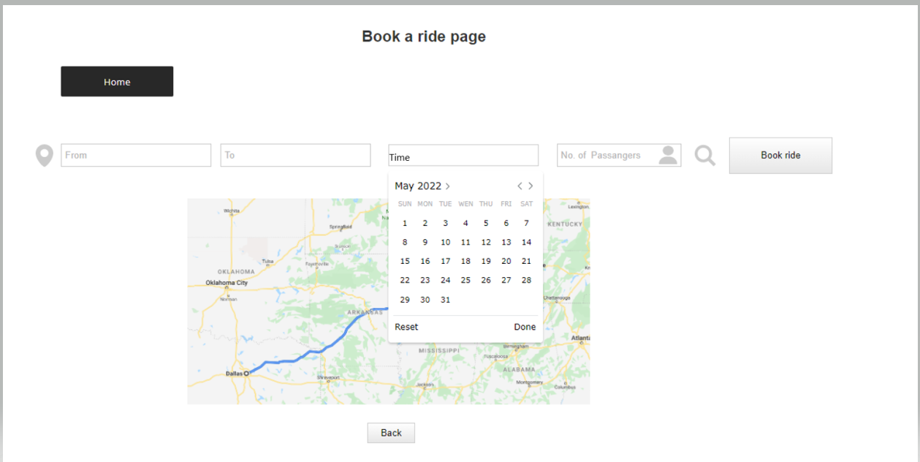

Payment
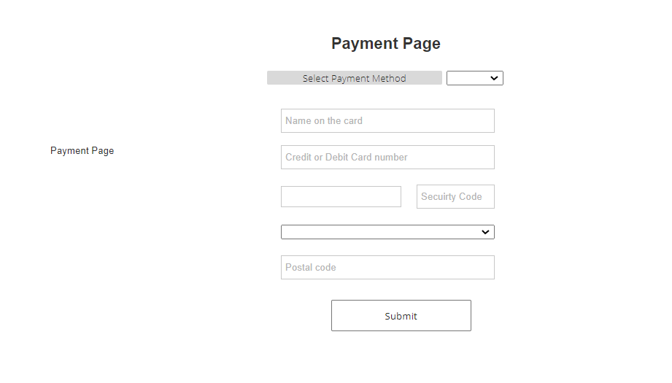

Rating

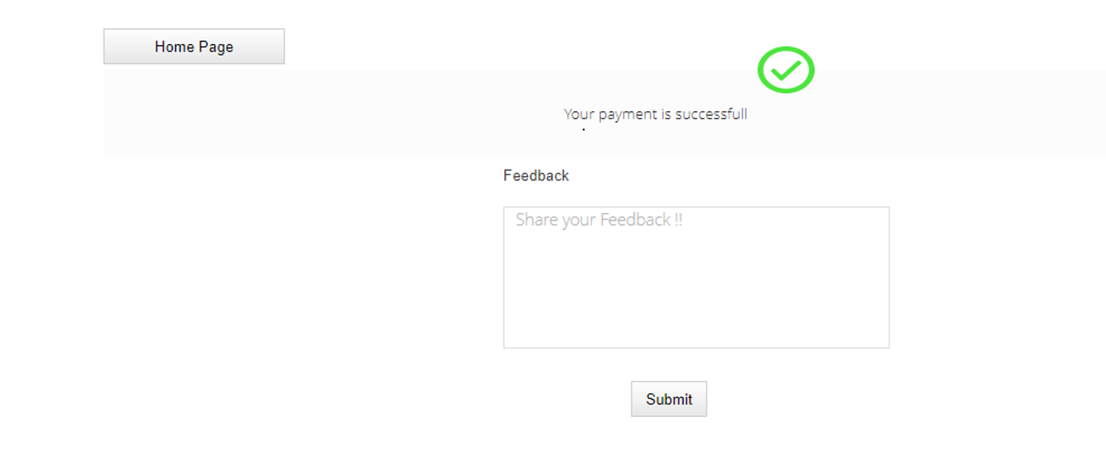

- Analysis Models

4.1. Data Flow Diagram

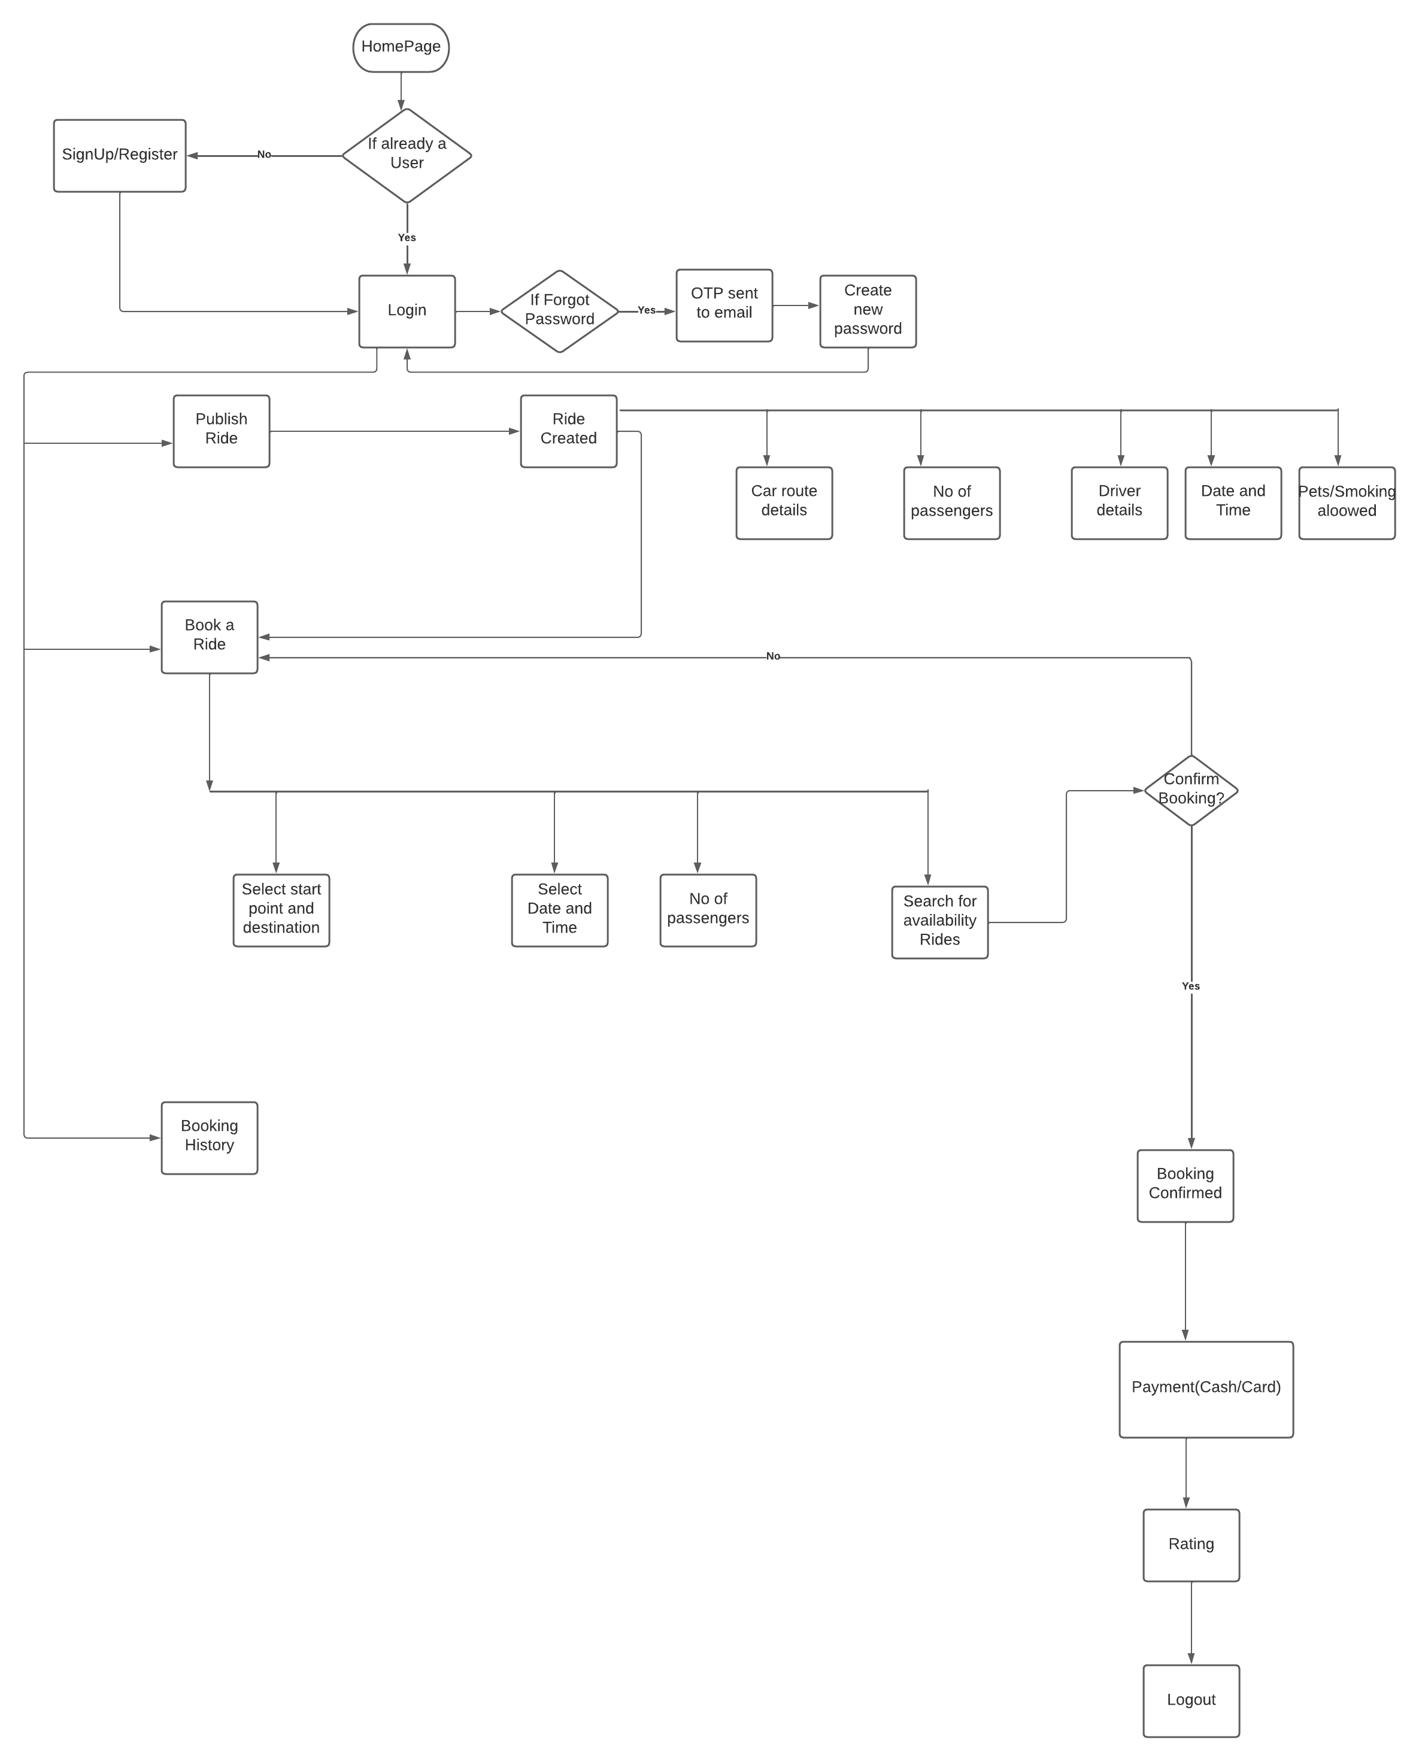
4.2. Sequence Diagram

